Section 3 – Brushes & Tools

# General Contents

They will go here

Contents

General Contents 1

3.1.1 Success Criteria Fulfilment Plan 4

**Feature** **Error! Bookmark not defined.**

**Proof** **Error! Bookmark not defined.**

**Code** **Error! Bookmark not defined.**

Section A - Brushes **Error! Bookmark not defined.**

Section B – Other editing tools **Error! Bookmark not defined.**

3.1.2 Section Decomposition 6

3.1.3 Class Design 7

3.1.3.1 IAction 7

Class Diagram 7

Methods 7

3.1.3.2 PixelAction 8

Class Diagram 8

Properties 8

Methods 8

3.1.3.3 ITool 9

Class Diagram 9

Properties 9

Methods 9

3.1.3.4 LineTool 10

Class Diagram 12

Properties 12

Methods 12

3.1.3.5 Layer 13

Class Diagram 13

Properties 13

3.1.3.6 BlankColour **Error! Bookmark not defined.**

3.1.4 Class Relation Diagram 14

3.1.5 Algorithm Design 15

Algorithm 3.1 Form Controls 16

Initial Design 16

Stakeholder feedback 17

Updated Design 17

Algorithm 3.2 Implementing Controls 18

3.2A Displaying Current Colour 18

3.2B Converting HSL to RGB 19

3.2C Generating the colour square 20

Algorithm 3.3 Returning Colour 22

Algorithm 3.4 Brush Size 23

3.4A Storing Current Brush 23

3.4B Constructing current brush 23

Algorithm 3.5 Brush Colour 25

Algorithm 3.6 Continuous Lines 26

3.6A Bresenham’s Line Algorithm 26

3.6B Setting the pixels 28

Algorithm 3.7 Designing Undo Interface 30

Algorithm 3.8 Implementing Undo Interface 30

3.8A New methods 30

3.8B Dealing with previous actions 30

3.1 Design

The brushes and tools section will contain many of the basic image editing tools, based upon the framework made in the previous section.

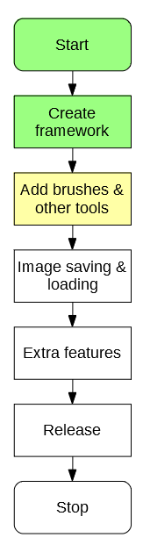

# 3.1.1 Success Criteria Fulfilment Plan

In this section the following success criteria are planned to be completed:

Not completed

To be done this section

Completed

|  |  |  |
| --- | --- | --- |
| **Feature** | **Proof** | **Code** |
| Section A - Brushes | | |
| Variable brush width | Screenshot of strokes of the same brush showing different widths | A1 |
| Hard brushes | Screenshot showing the hard edge of the brush (colour to no colour) | A2 |
| Shape creation tools | Screenshot showing the shape toolbar and a small selection of drawn shapes | A3 |
| Fill (bucket) tool | Screenshot showing a before and after of filling a large area | A4 |
| Single pixel pencil | Screenshot showing a stroke of the single pixel brush | A5 |
| Rubber | Screenshot showing a densely packed picture being rubbed out | A6 |
| Section B – Other editing tools | | |
| Image viewer | Screenshot of a currently being viewed image | B1 |
| Bitmap image editor | Screenshot of a zoom in on the image showing the pixels | B2 |
| RGB colour picker | Screenshot showing a system for entering an RGB colour | B3 |
| RGB direct input | Screenshot showing the user entering “FF0000” (or equivalent) and the programming outputting red | B4 |
| Layer system | Screenshot of layer navigator | B5 |
| Rectangle selection tool | Screenshot showing a rectangle selection on the image | B6 |
| Magic selection tool | Screenshot showing a complex selection around non-linear shape | B7 |
| Transparent pixels | Screenshot showing a layer with blank pixels (one layer on top of another). Partial transparency is not required | B8 |
| Zoom in (no zoom out) | Screenshot of an image at smallest zoom, followed by a screenshot at max zoom showing a portion of an image much smaller | B9 |
| Text | Screenshot of the text “Hello World” on the image | B10 |
| Eyedropper tool | Screenshot of an imported image, with the colour stroke of a colour taken from that image beneath it | B11 |
| *Image effects* | *Screenshot of an image before and after an effect is applied* | B12 |
| *Rotating Images* | *Screenshot of an image in 4 different rotations, normal, 90°, 180° and 270°* | B13 |
| *Clipping masks* | *Screenshot of an image being clipped onto a complex selection* | B14 |
| Section C – File System | | |
| Creating a new image | Screenshot of a blank 300x300 square image | C1 |
| Importing images | Screenshot of the file browser showing an image preview, and screenshot showing the image in the program | C2 |
| Exporting images | Screenshot showing a custom image in the program, followed by an image showing the file browser showing the image in a folder | C3 |
| Supporting PNG and JPEG | Screenshot showing the file browser which accepts both PNG and JPEG images | C4 |
| Saving and loading from a proprietary format | Screenshot showing the user saving an image, screenshot of the image in the file browser, and the program after the image is loaded | C5 |
| Section D – Usability | | |
| Program should be stable and not crash. | A complete testing table, showing no failed tests, followed 75% yes response to asking stakeholders “Did you encounter any errors while using the program?” | D1 |
| Program should be easy to use | 75% yes response to asking stakeholders “Did you find the program easy to use?” | D2 |
| Features should be easily accessible | From the default state of the program, any feature will need to be activated by no less than 4 clicks | D3 |

This should leave a reasonably functional (though not complete) editing program by the end of the section.

# 3.1.2 Section Decomposition

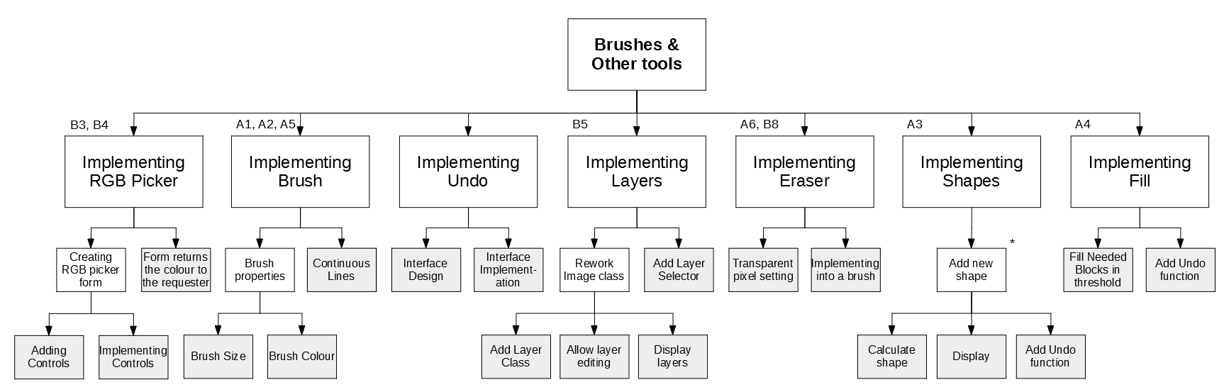

19

18

17

16

15

14

13

12

11

10

9

8

7

6

3

5

1

2

4

Each lowest level block has a label, which will become an algorithm designed in this document.

These algorithms will then be combined together.

# 3.1.3 Class Design

The necessary classes for this section are:

* IAction (for undo)
* PixelAction
* ITool
* IToolProperty
* NumericalProperty
* ColourProperty
* LineTool
* Layer

## 3.1.3.1 IAction

The IAction interface will encapsulate a generic action in the program. This enforces that every action in the program must have the possibility to be both done and undone.

### Class Diagram

<interface>

IAction

Do()

Undo()

### Methods

|  |  |  |  |
| --- | --- | --- | --- |
| **Method** | **Params** | **Return type** | **Justification** |
| Do() | Workspace workspace | None | Will do the action implemented by the action on the workspace |
| Undo() | Workspace workspace | None | Will undo the action implemented by the action on the workspace |

## 3.1.3.2 PixelAction

Implements IAction

Will encapsulate the concept of an action applied to the pixels of the image.

### Class Diagram

<class>

PixelAction

newPixels

oldPixels

Do*

Undo*

AddPixel()

### Properties

|  |  |  |
| --- | --- | --- |
| **Property** | **Datatype** | **Justification** |
| newPixels | Dictionary of FilePoint to Pixels | Stores a record of all the changes made to pixels |
| oldPixels | Dictionary of FilePoint to Pixels | Stores a record of what the pixels used to look like |

### Methods

|  |  |  |  |
| --- | --- | --- | --- |
| **Method** | **Params** | **Return type** | **Justification** |
| Do() | Workspace workspace | None | Inherited from IAction |
| Undo() | Workspace workspace | None | Inherited from IAction |
| AddPixel | FilePoint pixelLocation, Colour oldColour, Colour newColour | None | Adds a change of pixel to the record |

## 3.1.3.3 ITool

The ITool interface will implement the generic idea of a tool. This will be used by the tool checking code to decide what tool is active.

### Class Diagram

<class>

ITool

name

description

properties

HandleMouseDown

HandleMouseUp

HandleMouseClick

HandleMouseMove

GetProperty

### Properties

|  |  |  |
| --- | --- | --- |
| **Property** | **Datatype** | **Justification** |
| name | String | Stores the name of the tool to be displayed |
| description | String | Stores the description of the tool to be displayed |
| properties | List of ToolProperties | Stores the properties of that tool |

### Methods

|  |  |  |  |
| --- | --- | --- | --- |
| **Method** | **Params** | **Return type** | **Justification** |
| HandleMouseDown | FilePoint clickLocation, MouseButton button | None | Will run code when the mouse is pressed down |
| HandleMouseUp | FilePoint clickLocation, MouseButton button | None | Will run code when the mouse is released |
| HandleMouseClick | FilePoint clickLocation, MouseButton button | None | Will run code when the mouse is clicked |
| HandleMouseMove | FilePoint oldLocation, FilePoint newLocation | None | Will run code when the mouse is moved from one position to another |
| GetProperty | String propertyName | ToolProperty | Will return the specific property when asked for its name |

## 3.1.3.4 IToolProperty

The IToolProperty encapsulates a generic property that a tool may have, and can be further defined by specific implementations of the class. This means that there will be a common format for all tools.

### Class Diagram

<interface>

IToolProperty

name

### Properties

|  |  |  |
| --- | --- | --- |
| **Property** | **Datatype** | **Justification** |
| name | String | Stores the name of the property of the tool (e.g. size) |

## 3.1.3.5 NumericalProperty

The numerical property encapsulates a property that is represented by a number (e.g. thickness).

### Class Diagram

<class>

NumericalProperty

name*

value

min

max

### Properties

|  |  |  |
| --- | --- | --- |
| **Property** | **Datatype** | **Justification** |
| name* | String | Inherited from IToolProperty |
| value | Integer | Stores the value of the property |
| min | Integer | Stores the minimum value of the property |
| max | Integer | Stores the maximum value of the property |

## 3.1.3.6 ColorProperty

The numerical property encapsulates a property that is represented by a color (e.g. brush colour).

### Class Diagram

<class>

ColorProperty

name*

value

### Properties

|  |  |  |
| --- | --- | --- |
| **Property** | **Datatype** | **Justification** |
| name* | String | Inherited from IToolProperty |
| value | Color | Stores the value of the property |

## 3.1.3.7 LineTool

### Class Diagram

<class>

LineTool

name*

description*

properties*

HandleMouseDown*

HandleMouseUp*

HandleMouseClick*

HandleMouseMove*

GetProperty*

DrawLine

### Properties

|  |  |  |
| --- | --- | --- |
| **Property** | **Datatype** | **Justification** |
| name | String | Inherited from ITool |
| description | String | Inherited from ITool |
| properties | List of ToolProperties | Inherited from ITool |

### Methods

|  |  |  |  |
| --- | --- | --- | --- |
| **Method** | **Params** | **Return type** | **Justification** |
| HandleMouseDown | FilePoint clickLocation, MouseButton button | None | Inherited from ITool |
| HandleMouseUp | FilePoint clickLocation, MouseButton button | None | Inherited from ITool |
| HandleMouseClick | FilePoint clickLocation, MouseButton button | None | Inherited from ITool |
| HandleMouseMove | FilePoint oldLocation, FilePoint newLocation | None | Inherited from ITool |
| GetProperty | String propertyName | ToolProperty | Inherited from ITool |
| DrawLine | None | None | Draws the line when required |

## 3.1.3.8 Layer

### Class Diagram

<class>

LineTool

pixels

### Properties

|  |  |  |
| --- | --- | --- |
| **Property** | **Datatype** | **Justification** |
| pixels | Array of Colours | Stores the colours needed in this class |

# 3.1.4 Class Relation Diagram

Other actions in future

<class>

PixelAction

newPixels

oldPixels

Do*

Undo*

AddPixel()

<interface>

IAction

Do()

Undo()

<class>

ITool

name

description

properties

HandleMouseDown

HandleMouseUp

HandleMouseClick

HandleMouseMove

GetProperty

<class>

LineTool

name*

description*

properties*

HandleMouseDown*

HandleMouseUp*

HandleMouseClick*

HandleMouseMove*

DrawLine

Other tools in future

<class>

ITool

name

description

properties

HandleMouseDown

HandleMouseUp

HandleMouseClick

HandleMouseMove

GetProperty

<class>

ColorProperty

name

value

Other properties in future

<class>

NumericalProperty

name

value

min

max

# 3.1.5 Algorithm Design

## Algorithm 3.1 Form Controls

The algorithm form controls will be, from my analysis, inspired by the GIMP colour picker:

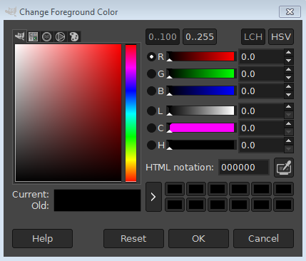

### Initial Design

#FF0000

### Stakeholder feedback

I showed the initial design to my stakeholders, and they had the following changes to be made:

* “An option to see your old colour would be good”
* “If there were separate editable boxes for the R, G and B values that would be nice”
* “Is the box for the code editable? It should be”
* “There should be a place that stores your recently used colours”

### Updated Design

Recent

255

0

0

#FF0000

## Algorithm 3.2 Implementing Controls

### 3.2A Displaying Current Colour

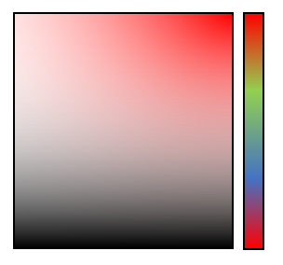

The colour space can be designed using the HSL colour format. This is where colour is split into Hue (H), Saturation (S) and Light (L). On the diagram these 3 colours can be represented like so:



Light

Saturation

Hue

### 3.2B Converting HSL to RGB

The algorithm for converting between HSL and RGB is

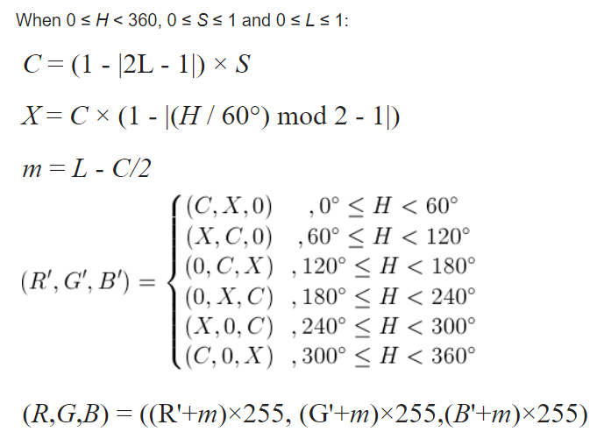

#### Pseudocode

Implementing the above diagram as pseudocode gives:

HSLtoRGB(H, S, L) {

C = (1 – Abs((2 * L) – 1)) * S

X = C * (1 – Abs(((H / 60) % 2) -1))

M = L – C/2

IF H < 60 THEN

r = C, g = X, b = 0

ELSE IF H >= 60 && H < 120 THEN

r = X, g = C, b = 0

ELSE IF H >= 120 && H < 180 THEN

r = 0, g = C, b = X

ELSE IF H >= 180 && H < 240 THEN

r = 0, g = X, b = C

ELSE IF H >= 240 && H < 300 THEN

r = X, g = 0, b = C

ELSE IF H >= 300 && H < 360 THEN

r = C, g = 0, b = X

END IF

R = (r + m) * 255

G = (g + m) * 255

B = (b + m) * 255

RETURN new Colour(R,G,B)

}

### 3.2C Generating the colour square

Now that HSL can be converted to RGB, the colour square can be generated reasonably simply:



#### Pseudocode

FOR x = 0 to 100

FOR y = 0 to 100

currentColour = HSLtoRGB(hue, x/100, y/100)

setPixel(x,y,currentColour)

NEXT

NEXT

The other controls are much more straightforward in design, so there is no merit in designing them here.

### Unit Test

|  |  |  |  |
| --- | --- | --- | --- |
| Test | ID | Expected Result | Comment |
| Set Hue to Red, click top-left corner | 1 | White | This tests that the top left corner is functional |
| Click top-right corner | 2 | Red | This tests that the top left corner is functional |
| Click bottom-left corner | 3 | Black | This tests that the bottom left corner is functional |
| Click bottom-right corner | 4 | Black | This tests that the bottom right corner is functional |
| Click three random positions on the colour square | 5 | Correct corresponding colour outputs | This tests that other areas on the colour square are valid |
| Click three random positions on the hue slider | 6 | Correct corresponding colour square, and output also changes | This tests that the hue slider can be changed and the rest of the form updates |
| Set RGB values to 255,0,0 | 7 | Red, hue adjusts appropriately | This tests that a standard colour can be implemented |
| Set RGB values to 255,255,255 | 8 | White | This tests that a maximum brightness colour can be implemented |
| Set RGB values to 0,0,0 | 9 | Black | This tests that the darkest colour can be entered |
| Set RGB values to -1,0,0 | 10 | Not accepted, round -1 to 0 | This tests that an incorrect value is adjusted up appropriately |
| Set RGB values to 256,255,255 | 11 | Not accepted, round 256 to 255 | This tests that an incorrect value is adjusted down appropriately |
| Set RGB values to 255,255 | 12 | Not accepted, missing value substituted for 0 | This tests that if a value is left out, it will be subsituted |

## Algorithm 3.3 Returning Colour

This will be implemented using the knowledge that in C# all classes (including colour) are passed by reference.

#### Pseudocode

So in the workspace form, the colour designer can be called by:

RGBPicker newPicker = new RBGPicker(colortochange)

RGBPicker’s constructor will look like so:

RGBPicker(color) {

storedColour = color

show form

}

Then RGBPicker will return the colour by setting storedColour to the result.

## Algorithm 3.4 Brush Size

### 3.4A Storing Current Brush

In order to determine the size of the brush, there must be a way to store what the brush looks like. In order to do this, there must be a store for the current brush.

#### Pseudocode

List currentBrush = new List of Points

currentBrush.Add(0,0) // brush has a set point at the origin

currentBrush.Add(-2,-2) // brush has a point 2 above and 2 to left of origin

currentBrush.Add(2,2) // brush has a point 2 below and 2 to right of origin

### 3.4B Constructing current brush

When generating brushes from certain sizes, it can be primarily planned by laying expectations:

|  |  |  |  |  |  |  |  |
| --- | --- | --- | --- | --- | --- | --- | --- |
|  |  |  |  |  |  |  |  |
|  |  |  |  |  |  |  |  |
|  |  |  |  |  |  |  |  |
|  |  |  |  |  |  |  |  |
|  |  |  |  |  |  |  |  |
|  |  |  |  |  |  |  |  |
|  |  |  |  |  |  |  |  |
|  |  |  |  |  |  |  |  |

Brush size 1

|  |  |  |  |  |  |  |  |
| --- | --- | --- | --- | --- | --- | --- | --- |
|  |  |  |  |  |  |  |  |
|  |  |  |  |  |  |  |  |
|  |  |  |  |  |  |  |  |
|  |  |  |  |  |  |  |  |
|  |  |  |  |  |  |  |  |
|  |  |  |  |  |  |  |  |
|  |  |  |  |  |  |  |  |
|  |  |  |  |  |  |  |  |

Brush size 2

|  |  |  |  |  |  |  |  |
| --- | --- | --- | --- | --- | --- | --- | --- |
|  |  |  |  |  |  |  |  |
|  |  |  |  |  |  |  |  |
|  |  |  |  |  |  |  |  |
|  |  |  |  |  |  |  |  |
|  |  |  |  |  |  |  |  |
|  |  |  |  |  |  |  |  |
|  |  |  |  |  |  |  |  |
|  |  |  |  |  |  |  |  |

Brush size 4

In this case, it is clear that the size of the brush is determined by its radius.

In order to start generating the brushes, an **exhaustion algorithm** can be used. In this case, every possible pixel that can be a part of the brush is tried, and if it is inside the circle, it is added to the dimensions of the brush.

In the case of the Brush Size 2, every point marked with an x is checked.

|  |  |  |  |  |  |  |  |
| --- | --- | --- | --- | --- | --- | --- | --- |
|  |  |  |  |  |  |  |  |
|  |  |  |  |  |  |  |  |
|  |  |  |  |  |  |  |  |
|  |  |  |  |  |  |  |  |
|  |  |  |  |  |  |  |  |
|  |  |  |  |  |  |  |  |
|  |  |  |  |  |  |  |  |
|  |  |  |  |  |  |  |  |

Generating the locations of these crosses is simple, the coordinated of each pixel is generated, and then 0.5 is added to centre it inside the pixel. This makes the pseudocode:

FOR x = brushSize*-1 TO brushSize

FOR y = brushSize*-1 TO brushSize

IF IsPointInCircle(x+0.5, y+0.5) THEN

currentBrush.Add(x,y)

END IF

NEXT

NEXT

To check whether a point is inside a circle, simple Pythagoras can be used. The points distance to the original can be calculated (x2 +y2), and if it is less than the brushSize2, then the point is inside the circle.

So again coming back to the size 2 brush:

|  |  |  |  |  |  |  |  |
| --- | --- | --- | --- | --- | --- | --- | --- |
|  |  |  | 1.5² + 1.5² = 4.5  4.5 > 4 so False |  |  |  |  |
|  |  |  |  |  |  |  |  |
|  |  |  |  |  |  | 1.5² + 0.5² = 2.5  2.5 < 4 so True |  |
|  |  |  |  |  |  |  |  |
|  |  | 0.5² + 0.5² = 0.5  0.5 < 4 so True |  |  |  |  |  |
|  |  |  |  |  |  |  |  |
|  |  |  |  |  |  |  |  |
|  |  |  |  |  |  |  |  |

In algorithmic form:

IsPointInCircle(x,y) {

IF ((x*x)+(y*y) <= (brushSize*brushSize)) THEN

RETURN true

ELSE

RETURN false

END IF

}

## Algorithm 3.5 Brush Colour

When needing to change the brush colour, the RGBPicker form can be created, and edited from there.

## Algorithm 3.6 Continuous Lines

This code is to fix a problem that was noted during the first session of stakeholder feedback.

“The current brush is a very simple affair, however it means that when drawing larger lines there is the potential for gaps. This will be resolved later when the brush is fully implemented”

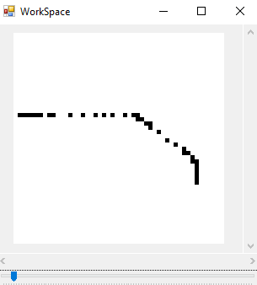

### 3.6A Bresenham’s Line Algorithm

In order to implement this, straight lines must be drawn between any gaps in the pixels. In order to draw straight lines in this case, an algorithm known as **Bresenham’s Line Algorithm** can be used. It is a well-established and efficient way of drawing a line between two points.

#### Psuedocode

DrawLine(x1,y1,x2,y2) {

If the second pixel is further left than the first, they are swapped. This decreases the amount of potential point configurations

IF x1 > x2 THEN

tempX = x1

tempY = y1

x1 = x2

y1 = y2

x2 = tempX

y2 = tempY

END IF

IF (x2 – x1) > Abs((y2 – y1)) // If change X is bigger than change Y

A = 2 x (y2 – y1)

B = A – (2 x (x2 – x1))

P = A – (x2 – x1)

currentY = y1

FOR currentX = x1+1 TO x2

IF P < 0 THEN

P += A

ELSE

IF (y2 > y1) THEN

currentY++

ELSE

currentY--

END IF

SetPixel(currentX,currentY)

P += B

END IF

NEXT

ELSE

A = 2 x (x2 – x1)

B = A – (2 x (y2 – y1))

P = A – (y2 – y1)

currentX = x1

FOR currentY = y1+1 TO y2

IF P < 0 THEN

P += A

ELSE

IF (x2 > x1) THEN

currentX++

ELSE

currentX--

END IF

SetPixel(currentX,currentY)

P += B

END IF

NEXT

END IF

}

### 3.6B Setting the pixels

When the brush is moved, the above algorithm can be used to set pixels between the points

#### Pseudocode

HandleMouseMove(oldPoint, newPoint) {

SetPixel(oldPoint.x, oldPoint.y)

DrawLine(oldPoint.x, oldPoint.y, newPoint.x, newPoint.y)

SetPixel(newPoint.x, newPoint.y)

}

### Unit Test

|  |  |  |  |
| --- | --- | --- | --- |
| Test | ID | Expected Result | Comment |
| Draw a 1 width line across middle of image | 1 | A line appears and is displayed on the image | This tests that a normal line can be drawn on the image |
| Draw a 1 width line at the edge of the image | 2 | A line is drawn at the edge | This tests that a normal line can be drawn at the edge of the image |
| Draw a 4 width line across middle of image | 3 | A thicker line is displayed on the image | This tests that a thick line can be drawn on the image |
| Draw a 4 width line at the edge of the image | 4 | A thicker line is displayed at the edge | This tests that a thick line can be drawn at the edge of the image |
| Move the mouse rapidly drawing a 1 width line | 5 | The drawn line has no visible breaks | This tests whether the filled line algorithm works correctly |
| Move the mouse rapidly drawing a 4 width line | 6 | The drawn line has no visible breaks | This tests whether the filled line algorithm works correctly with thicker brushes |

## Algorithm 3.7 Designing Undo Interface

The interfaces should be designed and implemented in accordance to class design 3.1.3.1 & 3.1.3.2. The reason for the implementation this way is to have a common method of performing (and undoing) any action in the program.

## Algorithm 3.8 Implementing Undo Interface

### 3.8A New methods

The workspace should then include three new public methods:

PerformAction(action) {

action.Do(this)

RecordAction(action)

}

PerformActionSilent(action) {

Action.Do(this)

}

RecordAction(action) {

The purpose of these two data structures will be explained in 3.8B

pastActions.add(action)

futureActions.flush()

}

The three methods are **justified** as:

* PerformAction is the general use action that will be performed and then recorded (in case it needs to be undone)
* PerformSilentAction is used in the case that an action is done to the image that should *not* be recorded, should be used very sparsely and in conjunction with RecordAction
* RecordAction is used after a silent action is performed, to make sure the action is recorded. These two alternatives are used when an action consists of many smaller actions, but only the larger change should be recorded (e.g. a brush draw may consist of many individual smaller line actions, but only the stroke as a whole should be recorded).

### 3.8B Dealing with previous actions

In order to implent the undoing and redoing that is needed by the program, two data structures are needed, being the pastActions and futureActions

|  |  |  |
| --- | --- | --- |
| **Property** | **Datatype** | **Justification** |
| pastActions | Stack of Actions | Stores the actions previously performed by the program. Only the last action needs to be accessed so a stack is needed |
| futureActions | Stack of Actions | Stores the actions that will be performed in the future, necessary for redoing (undo moves into the ‘past’, redo moves back from the past to its ‘future’, which is the present) |

In diagrammatic form, if the user draws three lines then the contents of the data structures should be:

LineAction2

LineAction3

futureActions

pastActions

LineAction1

Then if the user undoes two of those lines then two actions should be moved into the future:

LineAction1

futureActions

pastActions

LineAction3

LineAction2

Then if the user chooses to redo a line the first action from the future is popped

LineAction2

LineAction1

futureActions

pastActions

LineAction3

Finally, if the user makes a new line the futureActions stack is cleared, it’s no longer relevant.

LineAction4

LineAction2

LineAction1

futureActions

pastActions

Thus, the pseudocode for adding actions, undoing and redoing becomes:

RecordAction(action) {

pastActions.Push(action)

futureActions.Flush()

}

Undo() {

lastAction = pastActions.Pop()

lastAction.Undo()

futureActions.Push(lastAction)

}

Redo() {

nextAction = futureActions.Pop()

nextAction.Do()

pastActions.Push(nextAction)

}

### Algorithm 3.8C Implementing PixelAction

The PixelAction interface is designed to encapsulate any action that changes the pixels of the image, so implementing its Do() and Undo() methods is comparatively easy.

#### Pseudocode

Do() {

FOR EACH pixel IN newPixels

SetPixel(pixel.location,pixel.colour)

NEXT

}

Undo() {

FOR EACH pixel IN oldPixels

SetPixel(pixel.location,pixel.colour)

NEXT

}

### Unit Test

|  |  |  |  |
| --- | --- | --- | --- |
| Test | ID | Expected Result | Comment |
| Undo an action (on default image) | 1 | Cannot be done | Tests that an action cannot be undone if no action has been perfoemd |
| Redo an action (on default image) | 2 | Cannot be done | Tests that an action cannot be redone if there is no future |
| Perform an action | 3 | Action is performed onto image | Tests that actions can still be performed |
| Undo the action | 4 | Action is undone | Tests that an action can be undone |
| Redo the action | 5 | Action is redone | Tests that an action can be redone |
| Undo the action | 6 | Action is undone | Tests that a previously redone action can be undone |
| Redo the action | 7 | Action is redone | Tests that a previously undone action can be redone |
| Perform another action | 8 | Action is done | Tests that actions can still be done from here |
| Undo both actions | 9 | Both actions redone | Tests that multiple actions can be redone |
| Undo an action | 10 | Cannot be done | Tests that the program stops undoing when there are no previous actions |
| Redo both actions | 11 | Both actions redone | Tests that both actions can be redone |
| Redo an action | 12 | Cannot be done | Tests that the program stops redoing when there is no future |
| Undo an action, and preform a new action | 13 | New action is performed on top of old action | Tests that actions can be performed on a previously undone action |
| Redo an action | 14 | Cannot be done | Tests that the future is cleared when a new action is performed |

## Algorithm 3.9 Implementing Layer Class

The structure of the layer class can be implemented in accordance to 3.1.3.5

<class>

LineTool

pixels

Then the Image class should be updated to contain a list of layers, as well as a reference to its currentLayer

|  |  |  |
| --- | --- | --- |
| **Property** | **Datatype** | **Justification** |
| layers | List of Layers | Stores all of the image’s current layers |
| currentLayer | Layer | Contains a reference to the layer that is currently being edited |

## Algorithm 3.10 Allow layer editing

In order to achieve this, there must firstly be a way to change which layer is selected. This can be done using the following code:

ChangeLayer(newLayerID) {

currentLayer = layers[newLayerID]

}

Then to begin editing the layer, the SetPixel and GetPixel functions must be edited

SetPixel(location, colour) {

currentLayer.pixels[location] = colour

}

GetPixel(location) {

RETURN currentLayer.pixels[location] = colour

}

This means that **no functionality is lost** and despite internal changes, externally nothing has changed, meaning that the code is more compatible

## Algorithm 3.11 Display layer

In order to create the image now, when displaying a pixel each layer must be iterated through to find the first non-blank pixel, or in other words the process must look like:

|  |  |  |  |  |
| --- | --- | --- | --- | --- |
|  |  |  |  |  |
|  |  |  |  |  |
|  |  |  |  |  |
|  |  |  |  |  |

Layer 2

Layer 3

Layer 1

Where the layer blocks the view to the layer below it, when a non-transparent pixel is seen.

This makes the pseudocode:

DisplayPixel(x,y) {

FOR EACH layer IN layers

IF layer.pixels[x,y] is transparent

STOP REPEAT

ELSE

//Draw pixel on image (as before)

END IF

NEXT

}

## Algorithm 3.12 Add layer selector

In order to allow the user to manipulate the layer, a layer tool must be added that allows the user to select which layer is active, deselect the layer, and show/hide a layer. A potential design for this could look like:

### Initial Design



Layer 1

Layer 2





Layer 3

### Stakeholder feedback

After showing the stakeholders the design, I got the following feedback:

* “Looks solid, but will you be able to delete a layer?”
* “How can I deselect a layer?”
* “What about the rearranging tools, deleting and adding new layers?”

Addressing this feedback leads to:

### Updated Design



Layer 1

Layer 2





Layer 3



### 3.11A Drawing icon for layer

Each layer must contain a small icon to let the user know roughly what the layer looks like, drawing this image is much simpler as the entire image will always be displayed, the only difficulty will be downscaling the image to its smaller size.

A simple way to resolve this is to iterate through each pixel and find out which file pixel to draw from it, making the pseudocode:

DrawIcon() {

FOR x = 1 TO iconHeight

FOR y = 1 TO iconHeight

imageX = (x * imageWidth) / iconWidth

imageY = (y * imageHeight) / iconHeight

DrawRectangle(x,y,1,1,colours[imageX,imageY])

NEXT

NEXT

}

### Unit Test

|  |  |  |  |
| --- | --- | --- | --- |
| Test | ID | Expected Result | Comment |
| Select the top layer and draw onto it | 1 | There is drawing on layer | This tests whether a layer can be drawn onto |
| Attempt to delete the layer | 2 | The layer cannot be deleted as it is the only one | This tests whether the program is prevented from having 0 layers |
| Select lower layer and draw onto it at same location as top layer | 3 | There is drawing on lower layer, but it is obviously below | This tests whether the user can tell what layer they are drawing onto |
| Move lower layer up | 4 | The lower layers moves on top of previous top layer | This tests whether the drawing adjusts when the layers are moved |
| Move the highest layer up | 5 | Should be impossible as it cannot go up | This tests whether the highest layer cannot be moved too high |
| Move the lowest layer down | 6 | Should be impossible as it cannot go down | This tests whether the lowest layer cannot be moved too low |
| Add a new layer | 7 | A new (empty) layer is created | This tests whether a new layer can be made |
| Add 10 new layers | 8 | Many new layers are added | This tests whether the system can handle many layers |
| Layers are labelled then randomly rearranged | 9 | The layers are moved | This tests whether the program can handle moving many layers |
| The 11 layers are deleted | 10 | The layers disappear in the order in which they are added in the list | This tests that the order is maintained when removing many rearranged elements from the list |
| The final layer is deleted | 11 | Prevented as there is only one layer | This tests whether the removal prevention code still works |

## Algorithm 3.13 & 3.14 Implementing eraser

This was initially thought to be a more complex class, however the eraser can simply be implemented as a special LineTool, where its colour is set to Color.Transparent, which has an alpha (opaqueness) value of 0.

## Algorithm 3.15 Calculating Shapes

In order for the shape tool to work, there must be some simple shape calculation tools. Drawing from one of the image editing tools outlined in the analysis, **Paint**, there will be four implemented shapes:

* Line
* Rectangle
* Circle

### 3.15A Generic Shape Calculations

#### Common Class

In order for shapes to be implemented easily, there will be a base class that they inherit from IShapeTool, which inherits from IPixelTool, which inherits from ITool. This abstract class will encapsulate the generic process of adding a shape; click once, click somewhere else, shape is made. It will leave the calculations to make the shape up to its child classes. This means that the class will be implemented by:

<class>

IPixelTool

name*

description*

properties*

shapePoints

HandleMouseDown*

HandleMouseUp*

HandleMouseClick*

HandleMouseMove*

GetProperty*

DrawShape

SetShapePixel

AddShape

<class>

IShapeTool

name*

description*

properties*

point1

point2

shapePoints*

HandleMouseDown*

HandleMouseUp*

HandleMouseClick*

HandleMouseMove*

GetProperty*

DrawShape*

SetShapePixel*

AddShape*

The new properties are:

|  |  |  |
| --- | --- | --- |
| **Property** | **Datatype** | **Justification** |
| point1 | FilePoint | The location of the top-left corner of the shape |
| point2 | FilePoint | The location of the bottom-right corner of the shape |
| shapePoints | List of FilePoints | The points of the pixels that the shape will set |

|  |  |  |  |
| --- | --- | --- | --- |
| **Method** | **Params** | **Return type** | **Justification** |
| DrawShape | None (uses local Variables) | None | Draws the shape |
| AddShapePoint | Integer x, Integer y | None | Adds a point to be set to the shape. Will be outputted when AddShape is called |
| AddShape | None | None | Outputs the completed shape to the image |

#### Handling Clicks and resolving points

Handling the Click events is reasonably simple, just requiring a check for whether the first point has been set or not

HandleMouseClick(clickLocation, button) {

IF point1 is null THEN

point1 = clickLocation

ELSE

point2 = clickLocation

ResolveLocations()

DrawShape()

AddShape()

END IF

}

After the second point has been set, the shape is created. This requires two steps:

* Resolving the two points to make them uniform
* Drawing it

#### Resolving points

There is a need to resolve points, because it is unknown the order in which the user will create the two points, and there are four potential outcomes:

|  |  |  |  |  |  |  |  |  |  |  |
| --- | --- | --- | --- | --- | --- | --- | --- | --- | --- | --- |
|  |  |  |  |  |  |  |  |  |  |  |
|  |  |  |  |  |  |  |  |  |  |  |
|  | Point1  Point2 |  |  |  |  | Point1  Point2 |  |  |  |  |
|  |  |  |  |  |  |  |  |  |  |  |
|  |  |  |  |  |  |  |  |  |  |  |
|  |  |  |  |  |  |  |  |  |  |  |
|  |  |  |  |  |  |  |  |  |  |  |
|  | Point2  Point1 |  |  |  |  | Point2  Point1 |  |  |  |  |
|  |  |  |  |  |  |  |  |  |  |  |
|  |  |  |  |  |  |  |  |  |  |  |
|  |  |  |  |  |  |  |  |  |  |  |

Having four potential situations is not desirable, as it means programming for four cases. To resolve this, the points can be modified so that, no matter what, they look like the top-left situation.

In order to do that, the general algorithm must involve finding the highest and lowest out of each category, or in a flow chart:

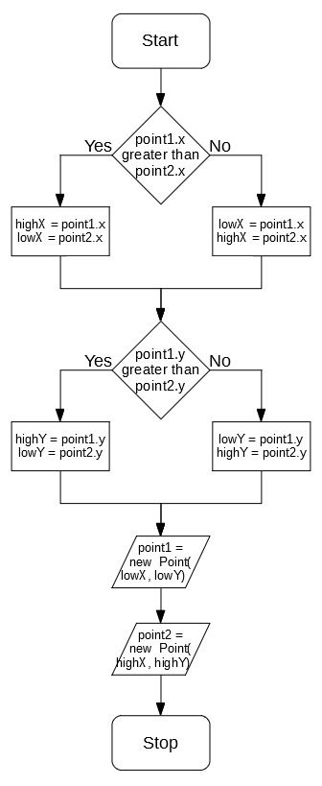

This now means that point1 will always have lower coords than point2

### 3.15B Line Drawing

LineDrawing can be accomplished by using Bresenham’s Line Algorithm code implemented previously in Algorithm 3.6, requiring no additional pseudocode

### 3.15C Rectangle Drawing

Drawing a rectangle between two points can be accomplished using iterations:

DrawShape() {

FOR x = point1.x TO point2.x

FOR y = point1.y TO point2.y

AddShapePoint(x,y)

NEXT y

NEXT x

}

### 3.15D Circle Drawing

Circle drawing is a more in-depth process, but can be implemented reasonably simply using a similar process to Algorithm 3.4. All potential candidate points are checked as to whether they appear in the circle (or ellipse) generated, if so, draw it.

This means a condition for an ellipse will need to be defined. In order to do this a standard representation can be used:

$$\frac{{(x-\left(x^{'}+0.5\right))}^{2}}{w^{2}}+ \frac{{(y-(y^{'}+0.5))}^{2}}{h^{2}}≤1$$

Representation of a sphere of width w and height h with a centre of (x’,y’)

0.5 is subtracted from each point in order to make sure the *centre* of each pixel is checked, as this most accurately represents where the pixel should go, and means there is no bias between top left pixels and bottom right pixels.

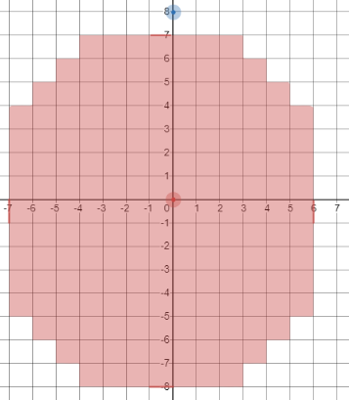

*Without correction*

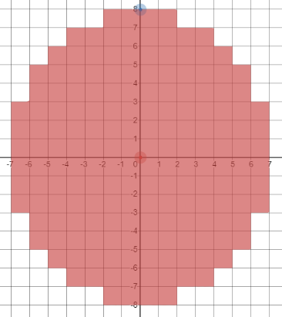

*With correction*

So every potential x and y can be checked to see if it satisfies that condition, if so, draw the circle

DrawShape() {

centreLocX = (point1.X + point2.X)/2 + 0.5

centreLocY = (point1.Y + point2.Y)/2 + 0.5

widthSquared = (point2.X – point1.X) ^ 2

heightSquared = (point2.Y – point1.Y) ^ 2

FOR x = point1.X TO point2.X

FOR y = point1.Y TO point2.Y

IF ((x – centreLocX) ^ 2) / widthSquared +

((y – centreLocY) ^ 2) / heightSquared <= 1 THEN

AddShapePoint(x,y)

END IF

NEXT y

NEXT x

}

### Unit Test

|  |  |  |  |
| --- | --- | --- | --- |
| Test | ID | Expected Result | Comment |
| Create line with points (5,5) & (10,10) | 1 | A line is drawn from (5,5) to (10,10) | This tests that a line can be created using an above left first point |
| Create line with points (5,10) & (10,5) | 2 | A line is drawn from (5,10) to (10,5) | This tests that a line can be created using an below left first point |
| Create line with points (10,5) & (5,10) | 3 | A line is drawn from (10,5) to (5,10) | This tests that a line can be created using an below right first point |
| Create line with points (10,10) & (5,5) | 4 | A line is drawn from (10,10) to (5,5) | This tests that a line can be created using an above right first point |
| Create line with points (5,5) & (10,8) | 5 | A shorter line is drawn | This tests that a shorter, non-square line can be drawn |
| Create line with points (5,5) & (8,10) | 6 | A thinner line is drawn | This tests that a thinner, non-square line can be drawn |
| Create line with points (5,5) & (10,5) | 7 | A single row is drawn | This tests that a shape can be drawn that has same Y |
| Create line with points (5,5) & (5,10) | 8 | A single column is drawn | This tests that a shape can be drawn that has same X |
| Create rectangle with points (5,5) & (10,10) | 9 | A rectangle is drawn from (5,5) to (10,10) | This tests that a rectangle can be created using an above left first point |
| Create rectangle with points (5,10) & (10,5) | 10 | A rectangle is drawn from (5,10) to (10,5) | This tests that a rectangle can be created using an below left first point |
| Create rectangle with points (10,5) & (5,10) | 11 | A rectangle is drawn from (10,5) to (5,10) | This tests that a rectangle can be created using an below right first point |
| Create rectangle with points (10,10) & (5,5) | 12 | A rectangle is drawn from (10,10) to (5,5) | This tests that a rectangle can be created using an above right first point |
| Create rectangle with points (5,5) & (10,8) | 13 | A shorter rectangle is drawn | This tests that a shorter, non-square rectangle can be drawn |
| Create rectangle with points (5,5) & (8,10) | 14 | A thinner rectangle is drawn | This tests that a thinner, non-square rectangle can be drawn |
| Create rectangle with points (5,5) & (10,5) | 15 | A single row is drawn | This tests that a shape can be drawn that has same Y |
| Create rectangle with points (5,5) & (5,10) | 16 | A single column is drawn | This tests that a shape can be drawn that has same X |
| Create circle with points (5,5) & (10,10) | 17 | A circle is drawn from (5,5) to (10,10) | This tests that a circle can be created using an above left first point |
| Create circle with points (5,10) & (10,5) | 18 | A circle is drawn from (5,10) to (10,5) | This tests that a circle can be created using an below left first point |
| Create circle with points (10,5) & (5,10) | 19 | A circle is drawn from (10,5) to (5,10) | This tests that a circle can be created using an below right first point |
| Create circle with points (10,10) & (5,5) | 20 | A circle is drawn from (10,10) to (5,5) | This tests that a circle can be created using an above right first point |
| Create circle with points (5,5) & (10,8) | 21 | A shorter circle is drawn | This tests that a shorter, non-square circle can be drawn |
| Create circle with points (5,5) & (8,10) | 22 | A thinner circle is drawn | This tests that a thinner, non-square circle can be drawn |
| Create circle with points (5,5) & (10,5) | 23 | A single row is drawn | This tests that a shape can be drawn that has same Y |
| Create circle with points (5,5) & (5,10) | 24 | A single column is drawn | This tests that a shape can be drawn that has same X |

## Algorithm 3.16 Display & Algorithm 3.17 Log Undo

This can be accomplished by implementing the AddShapePoint function, as it needs to log any set pixels into a list

AddShapePoint(x,y) {

shapePoints.Add(new FilePoint(x,y))

}

This means that any points are logged and then eventually outputted. To output them, this list can be iterated through to create a PixelAction object which will be executed by the image.

AddShape() {

newAction = new PixelAction()

newColour = GetProperty(“colour”)

FOR EACH shapePoint IN shapePoints

oldColour = image.GetPixel(x,y)

newAction.AddPixel(x,y,oldColour,newColour)

NEXT shapePoint

image.PerformAction(newAction)

}

This demonstrates how the existing action classes can be used to safely perform an edit to the image.

## Algorithm 3.17 & Algorithm 3.18 Fill Tool

In order to implement the fill tool, a simple algorithm will be used. This is to save on programming time and a faster algorithm may not make much difference.

The FillTool will inherit from the existing IPixelTool. This makes the inheritance tree for the current tools:

<class>

LineTool

<class>

RectangleTool

<class>

CircleTool

<class>

IShapeTool

<class>

FillTool

<class>

IPixelTool

<class>

ITool

In order to create the fill algorithm, a simple structure will be used. When clicking on a starting point, that point will be parsed, and then the four adjacent points will be parsed, and so on, until the algorithm is complete.

In flowchart form, the algorithm for this becomes:

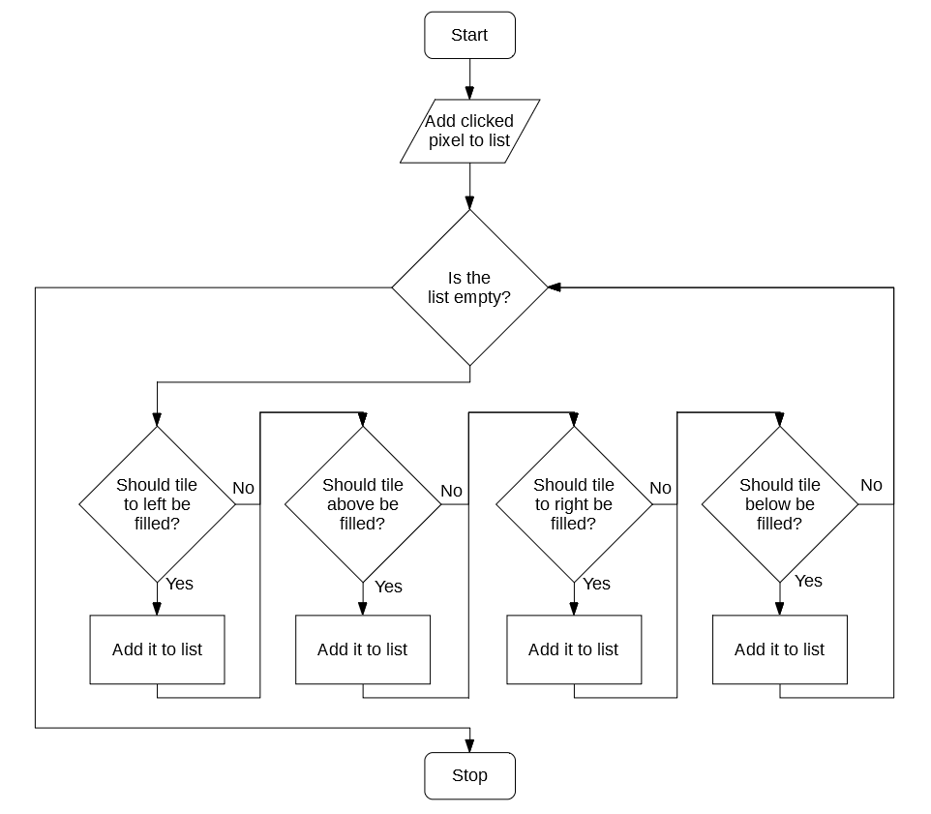

In order to determine whether a tile should be added to the list, the following algorithm can be used:

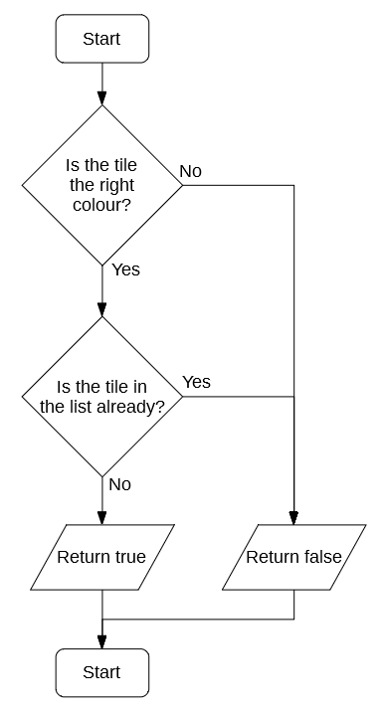

Stop